HANOI UNIVERSITY OF SCIENCE AND TECHNOLOGY

School of Information and Communications Technology

ITSS Software Development Report

**EcoBikeRental**

Subject: Software Development

Instructor: Prof. Trinh Tuan Dat

Student: Phạm Văn Khoa - 20176796

*Hanoi, December 2020*

# Assigned Use Case: User return bike.

## Use case diagram:

### General use case diagram:

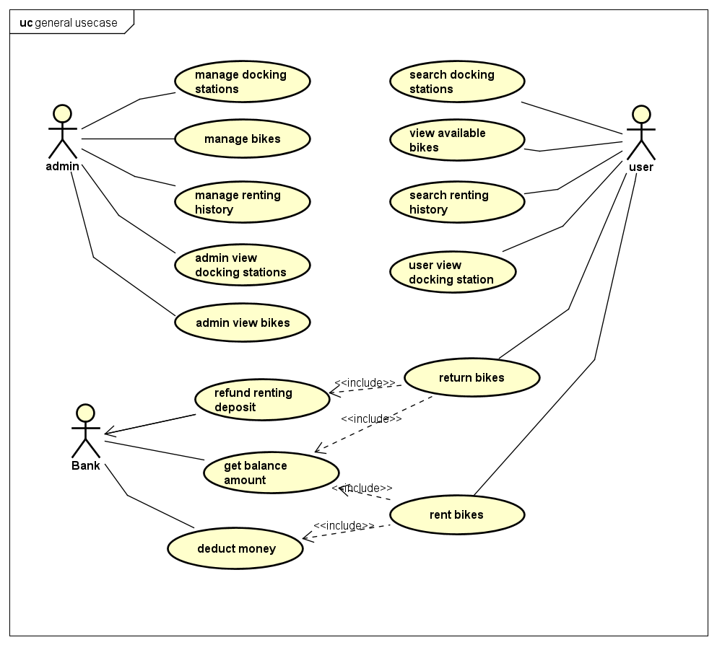

### Use case diagram for “Return bikes” :

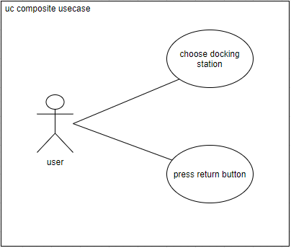

## Use case specification:

### Use case “Insert Credit Card Number”:

|  |  |  |  |
| --- | --- | --- | --- |
| UC Code | UC001 | Use case name | User Return Bike |
| Actor | User | | |
| Precondition | Rented a bike | | |
| Main flow of event  (success) | |  |  |  | | --- | --- | --- | | # | Doer | Action | |  | User | Press “Return bike” button. | |  | System | Display “Rental Details” dialog. | |  | User | Choose which docking station to return bike. | |  | User | Press “Pay and return” button. | |  | System | Refund deposit money. | |  | System | Deduct renting money. | |  | System | Save new rental. | | | |
| Alternative flow of event | |  |  |  |  |  | | --- | --- | --- | --- | --- | | # | | Doer | | Action | | 3a | System | | Show diaglog “Docking station empty dock left”. | | | 6a | System | | Show dialog “Credit card balance insufficient!”. | | | | |
| Post condition | No | | |

# Diagrams

## Sequence Diagram for Analysis Class:

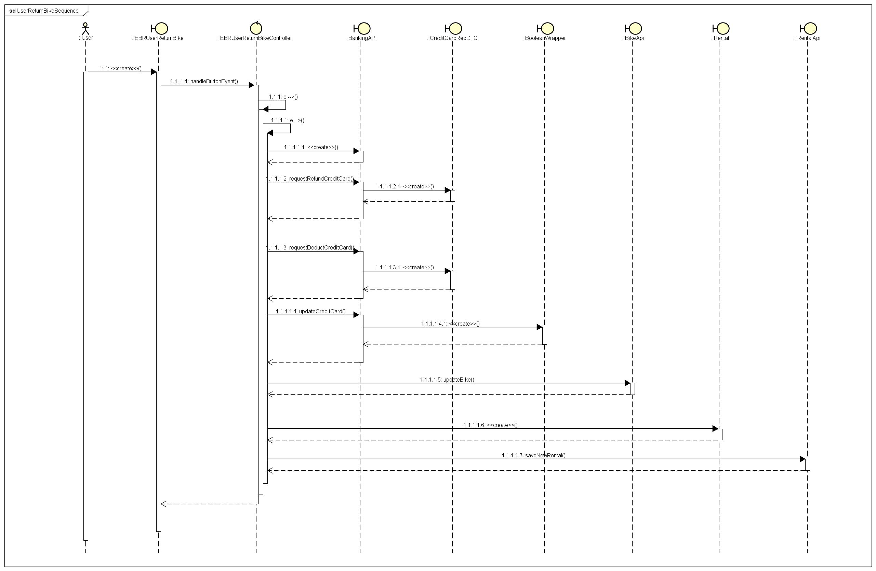

## Analysis Class Diagram:

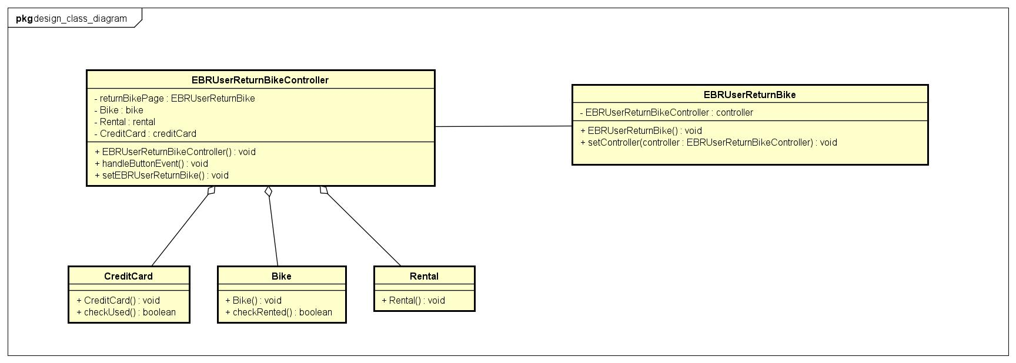

## Package Diagram:

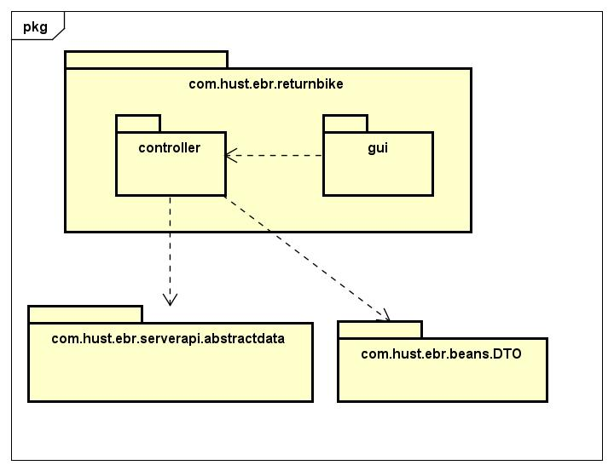

## Sequence Diagram for Design Class:



## Design Class Diagram:

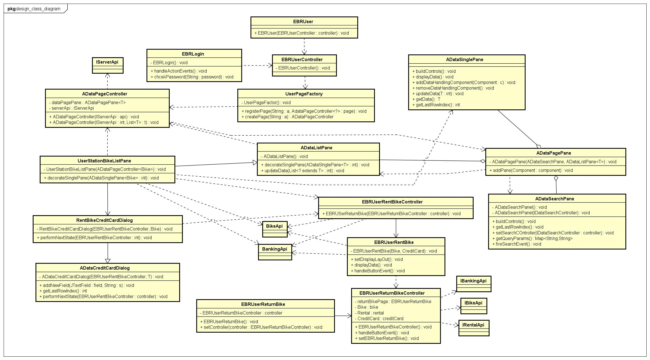

## Unit Testing

|  |  |  |  |  |  |
| --- | --- | --- | --- | --- | --- |
| **Test Case Name:** User Return Bike | | | **Technique applied:** Black Box | | |
| **Description:** Test the return bike function. | | | | | |
| **Pre-conditions:** Succesfully rented a bike. | | | | | |
|  | | | | | |
| **Step** | **Action** | **Expected System Response** | | **Pass/Fails** | **Comment** |
| 1 | Choose a docking station that is out of slot to return bike. | A dialog shows up “Docking station no empty dock left”. | | pass |  |
| 2 | Use an low balance credit card and press “PAY AND RETURN” button. | A dialog shows up ”Credit card balance insufficient”. | | pass |  |
|  |  |  | |  |  |